

**Name:** Fatima Malik

**Sap ID:** 40089

**Semester:** BSCS-6

**Course:** Computer Networks

**Lab 9**

**Solution:**

Task 1:

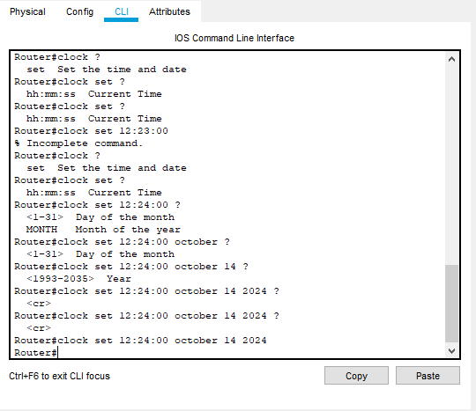

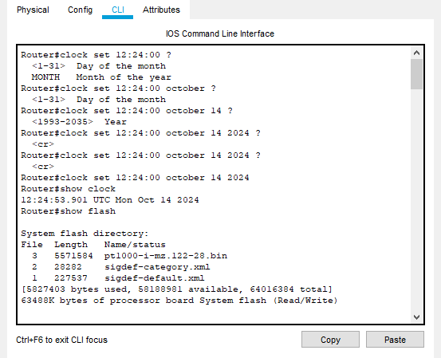

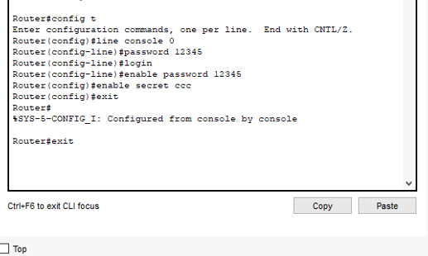

Task 2:

Output from PC 1 to PC 2:

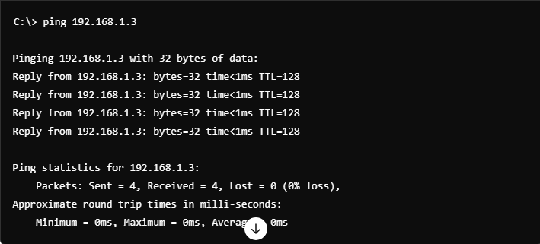

Output from PC 2 to PC 1:

